**Project Design Phase-II**

**Third-Party API’s**

|  |  |
| --- | --- |
| **Date** | **02 November 2023** |
| **Github name** | [**74BC4F37853BF1E8045468DA6E31B6A0-SALESFORCE**](https://github.com/Kiruthikaduraiyarasan/74BC4F37853BF1E8045468DA6E31B6A0-SALESFORCE/tree/main) |
| **Project Name** | Recruiting Assistance For The HR Managers |

**Third-Party API’s**

Integrating third-party APIs into your CRM application for managing loan applications and preventing fraudulent activities can enhance its functionality and efficiency. Here are some third-party APIs that you can consider integrating into your CRM system:

Credit Bureau APIs:

Equifax, Experian, TransUnion: Credit reporting agencies provide APIs that allow you to access credit reports and scores for credit checks, risk assessment, and creditworthiness evaluation.

Payment Processing APIs:

Stripe, PayPal, Square: Payment processors offer APIs for handling loan disbursements, repayments, and transaction processing.

Identity Verification APIs:

IDology, Jumio, Onfido: Identity verification services offer APIs to verify the identity of loan applicants by comparing their provided information to various databases and documents.

Document Verification APIs:

DocuSign, Adobe Sign: Document verification APIs allow you to collect electronic signatures and manage loan-related documents securely.

Geolocation APIs:

Google Maps, Mapbox: Geolocation APIs can help you verify the physical location of loan applicants and assess the risk associated with their location.

SMS and Email Communication APIs:

Twilio, SendGrid: These APIs can be used for sending notifications, alerts, and communication to loan applicants and users.

Fraud Detection APIs:

Kount, Sift Science: Fraud detection and prevention services offer APIs that use machine learning and real-time analysis to identify fraudulent activities and protect your CRM application from potential threats.

Regulatory Compliance APIs:

Compliance.ai: This API can help you monitor and stay up to date with regulatory changes, ensuring that your CRM application complies with relevant laws and standards.

External Data APIs:

Public Data Sources: Depending on your requirements, you may need to integrate external data sources like government databases, property records, or industry-specific data sources to verify information provided by applicants.

Email Verification APIs:

ZeroBounce, Hunter: Email verification APIs can help you ensure that the email addresses provided by loan applicants are valid and active.

Social Media APIs:

Integrating with social media APIs can provide insights into the online presence and behavior of loan applicants, which can be useful for fraud prevention and risk assessment.

SMS and Email Verification APIs:

APIs like Twilio, Nexmo, and SendGrid offer verification capabilities, allowing you to confirm the contact information provided by loan applicants.

Machine Learning and AI APIs:

Services like AWS Machine Learning, Google Cloud AI, and IBM Watson offer APIs for building and deploying machine learning models for fraud detection and risk assessment.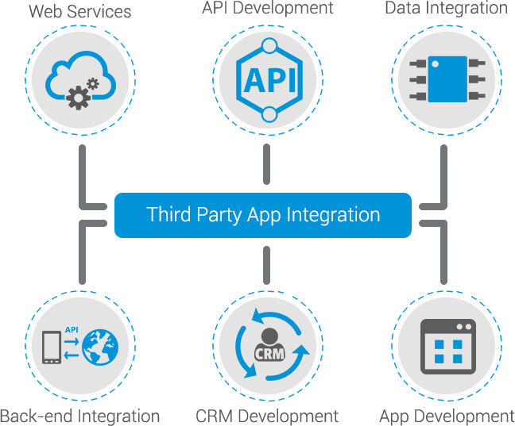

Communication and Notification APIs:

Consider integrating APIs like Pusher or Firebase Cloud Messaging for real-time communication and notifications to keep users informed about their loan application status.

Document Storage and Management APIs:

Cloud storage services like Amazon S3, Google Cloud Storage, or Dropbox offer APIs that you can use for secure document storage and retrieval.

Data Enrichment APIs:

APIs like Clearbit or FullContact can provide additional data about loan applicants, helping you make more informed lending decisions.

When integrating third-party APIs into your CRM application, make sure to carefully review their documentation, pricing, and terms of use. Additionally, consider the security and privacy implications of the data you'll be sharing with these external services and ensure compliance with relevant regulations, such as GDPR or HIPAA, where applicable. Properly managing API integrations is essential for a seamless and secure user experience.